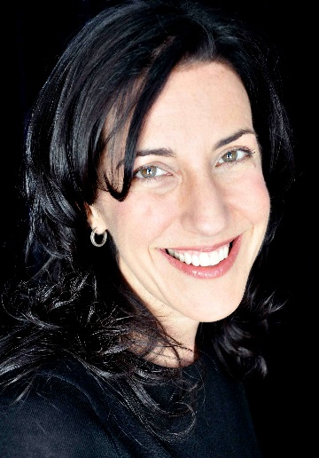

Tracy Katsky has launched her own production company, KatCo. In a very unusual arrangement between two independent producers, Katsky is joining Aaron Kaplan, with her KatCo. functioning as a pod at Kaplan’s Kapital Entertainment (The Mysteries of Laura, Secrets & Lies, Instant Mom). Under the one-year agreement, all projects Katsky develops will be produced by KatCo in association with Kapital Entertainment. Kaplan also might bring Katsky in to produce some of Kapital’s projects with him. “It’s so exciting to launch my own company, and to do it with Aaron is just amazing,” Katsky said. “What he has done with Kapital in such a short time is an incredible example of how to build a company, and I am thrilled to be working with him to launch KatCo.” Katsky, who starts on Tuesday, will be based at Kapital’s offices in West Hollywood. The setup resembles a standard pod deal, with four-year-old Kapital Entertainment serving as a studio. It might be providing a glimpse into Kaplan’s plans to grow his independent production company into a full-fledged studio. “I’m beyond excited that Tracy chose Kapital as the place to build her new company,” Kaplan said. “She is one of the great development minds in our business, and I know that will translate perfectly into her new venture with KatCo.”
A sought-after development executive, Katsky most recently with Greg Daniels at production company Deedle Dee Prods, where she worked on a number of projects, including the upcoming NBC comedy series Mr. Robinson. Previously, WME-repped Katsky did a four-year stint as SVP Development & Original Programming at Nickelodeon. Before that, she was SVP Development for HBO Independent Prods, SVP and head of comedy for Fox and SVP and head of comedy for Regency TV.

