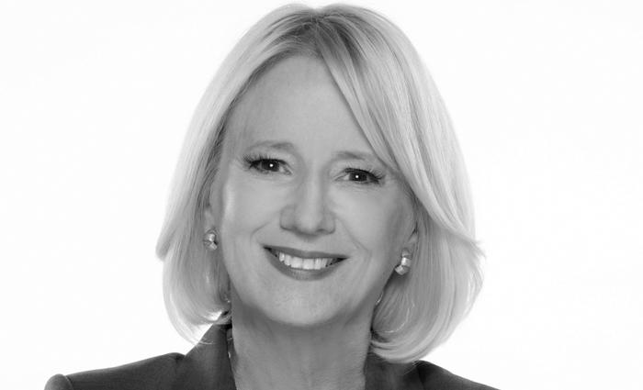
RENEE WHITE FRASER
Ph.D. - President & CEO
Founder and CEO Renee White Fraser believes communication can improve the world. She was honored as one of the "50 Most Influential Women” by Los Angeles Magazine for her many contributions in civic leadership (United Way board, VOA National board and Co-Chair of Business Task Force to end homelessness in L.A./Home for Good). Renee encourages entrepreneurship through her radio show “UnFinished Business” on CBS.

